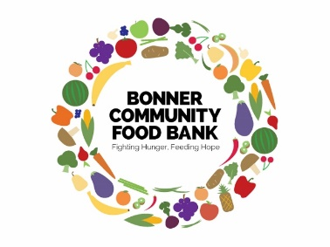

Bonner Community Food Bank

1707 Culvers Dr., Sandpoint, ID 83864 - (208) 263-3663

[www.bonnerfoodbank.org](http://www.bonnerfoodbank.org) - [info@bonnercommunityfoodbank.org](mailto:info@bonnercommunityfoodbank.org)

Today’s Date_____________________

I need to complete community service hours: Court appointed Education

Number of hours needed _______________Completion date________________________

Name:________________________________________________________ Phone:___________________________

Email:_____________________________________________________ Date of Birth:_________________________

Address:_________________________________________________ City: ____________________ZIP:___________

Emergency Contact:________________________________________________Phone:_______________________

Physicians Name:__________________________________________________ Phone:________________________

Please circle the day(s) that you are available to volunteer:

**Monday Tuesday Weds Thursday Friday**

Morning Morning Morning Morning Morning

Afternoon Afternoon Afternoon Afternoon Afternoon

|  |
| --- |
| Please tell us about any special skills or certifications that you are willing to utilize when volunteering at the food bank: |
| Previous volunteer experience: |
| Physical limitations such as lifting, allergies, etc.: |

Signature____________________________________________________ Date__________________________



Bonner Community Food Bank

1707 Culvers Dr., Sandpoint, ID 83864 • (208) 263-3663

www.bonnerfoodbank.org • [info@bonnercommunityfoodbank.org](mailto:info@bonnercommunityfoodbank.org)

**Volunteer Job Description**

**Job Title:**

Food Bank Volunteer

**Project/Purpose:**

The purpose of the Bonner Community Food Bank is to assist persons in our community with

emergency non-medical resources in a time of personal crisis.

**Position Summary:**

Under the supervision of the Food Bank Director and staff, volunteers will assist the food bank

with general duties to provide optimum service to our community and ensure the efficient

operation of the food bank.

**Responsibilities:**

* Accept and weigh food donations.
* Stock shelves and arrange food on shelves as appropriate.
* Sort grocery store and food drive donations.
* Greet the public and distribute food.
* Assist with administrative staff duties as needed.
* Perform janitorial duties.
* Work in office and/or warehouse conditions.
* Work on food drives, if available
* Assist with other duties or special projects as needed.

**Requirements:**

* 16 years of age (except under special arrangement)
* Wear comfortable, durable clothing suitable for movement.
* Wear durable, comfortable closed toe shoes (very important)

**Qualifications:**

* Effective interpersonal and verbal skills
* Willing to work with people from diverse economic, racial and cultural backgrounds.
* A passion for helping those less fortunate in our community.
* Ability to lift a maximum of 40 lbs.
* May be required to bend, reach, and stoop.
* Ability to follow directions.

**Time Commitment:**

Volunteers are typically scheduled for half-day or full day shift.